OPSC6311 POE Part 1

Members include:  
Aaron Adams St10376245 (Project Leader)  
Joel Mbaya ST10390852  
Kamvalethu Mdanjelwa ST10377628  
Neville Kalala ST10346082  
David Ayowa ST10368326

# Planning and Design

**INTRODUCTION:**

### Introduction to Pocket Saver Budget

**Pocket Saver Budget** is a smart and easy-to-use app designed to help you manage your money wisely. With this app, you can track your expenses, set monthly budgets, and monitor your spending through detailed graphs. It also includes features like grocery list planning, savings insights, and a rewards system to keep you motivated. Simply sign up, secure your data, and start taking control of your finances. **Pocket Saver Budget makes saving money simple and effective**

* To help people manage their finances and know how to spend or spend their money, we have developed an app called Pocket Saver Budget. As you can see from this, it has many features in addition to the ability to control and use financial resources. Because we didn't make a typical app, but rather one that should save you from every situation, users will be able to do more with this app than they had anticipated. You have control over your spending and can see your past spending. Create a grocery list so you can monitor your spending and prevent overspending. An expense graph that compares your monthly expenses to previous months allows you to see your progress over time, including whether you stayed within your spending limit. We also created a rewards section that can help users by informing them of the estimated amount of savings they have made. Who knows, maybe saving that one rand could have made you a millionaire in ten years. However, once a user has signed up for the app, all of the information is accessible. Think of it as a regular sign-in page or clock-in at work, but with a far better experience utilizing the app, and you can be one step closer to saving the money you've always desired.

* The following features will be included in the app: a website for registration and login where users can store all of their information and keep their budget app safe. Categories will be created for things like entertainment and grocery lists. Finally, the app will undoubtedly have a gamification component. Other features will include an add expense function, monthly goal budget, and a list of all expenses that the user can view. All of this data will be saved to a local database and displayed on a graph.

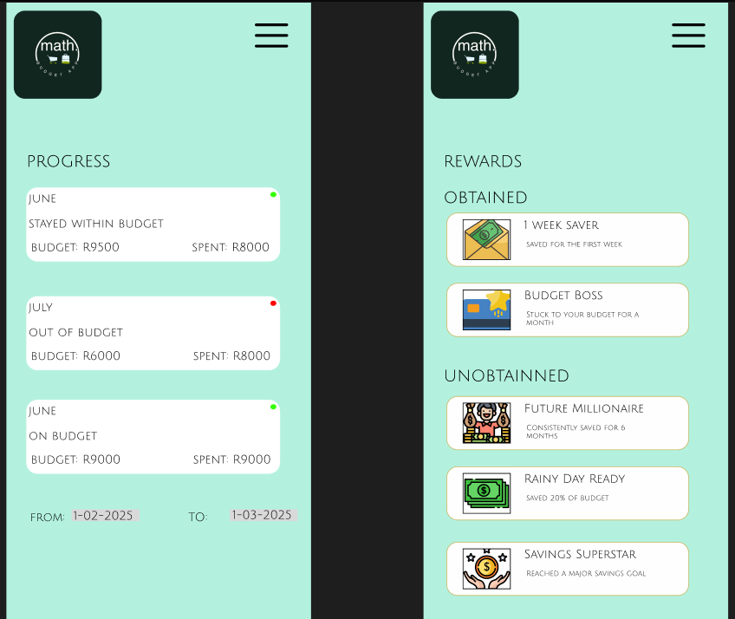Progress Page

The user can then access this page to track the progress tracking of the user and to see if they are still on track with the spending goals indicated by the green or red dots on the top right of each task.

Rewards Page

On this page the user can then get a glance at their achievements in the form of rewards both obtained and unobtained.

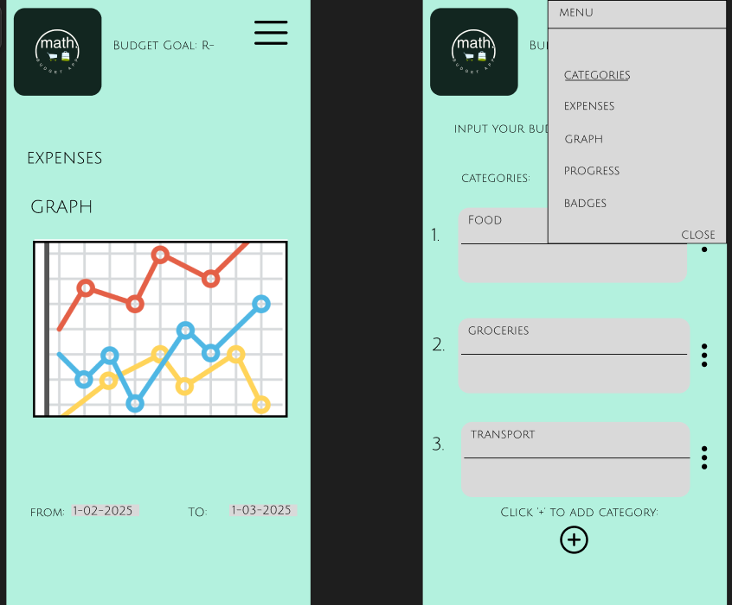Graph Page

This page shows the expense graph that shows the trend of spending for the user for a user selectable period.

Drop Down Menu

This page shows the drop down menu that a user can select to choose from the options to quickly navigate to the desired page (This will be used as the navigation hub to the entire app).

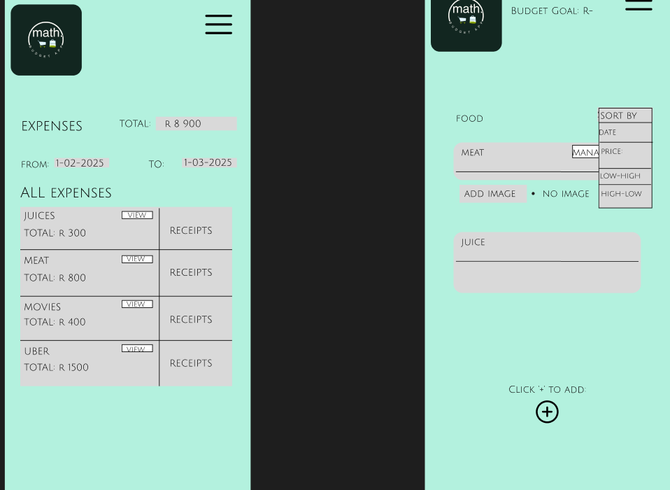Expenses Page

This page informs the user of all the list items in the categories along with a glance at the receipts and amounts of the individual items in the categories allowing the user to be able to view all items immediately.

Drop Down Menu

This drop-down menu will be for sorting the list of the items by the date, price.

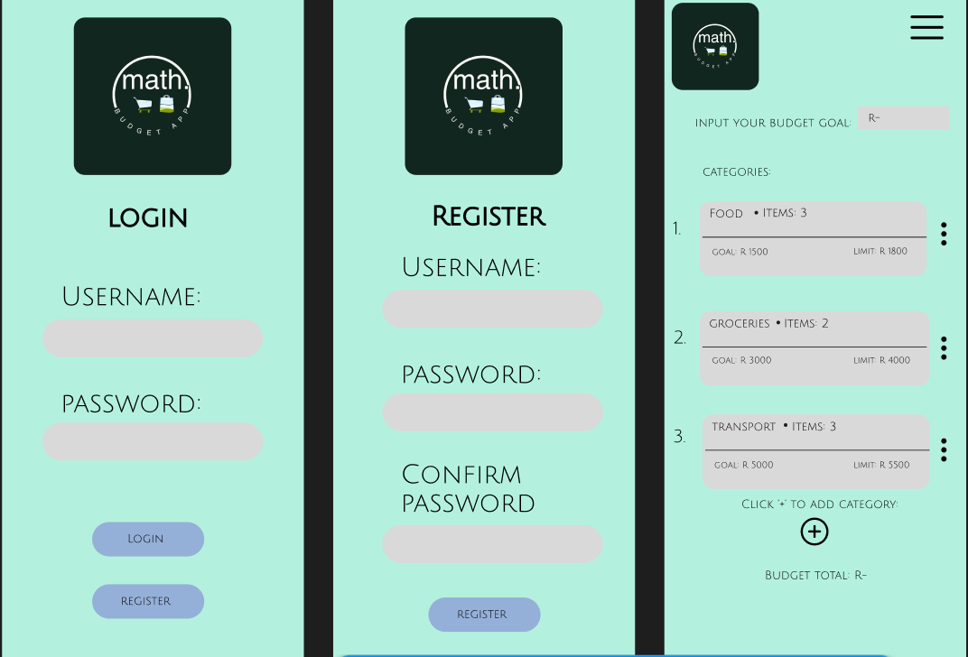

Login Page

Users enter their username and password to log in.

Navigation: If successful, they go to the Home/Dashboard. If not, they receive an error.

Button Options:

Login → Home/Dashboard

Register → Registration Page

Register Page

Users input username, password, and confirm password to create an account.

Navigation:

Successful registration → Home/Dashboard

Back → Login Page

Expenses Page

This page informs the user of all the list items in the categories along with a glance at the receipts and amounts of the individual items in the categories allowing the user to be able to view all items immediately.

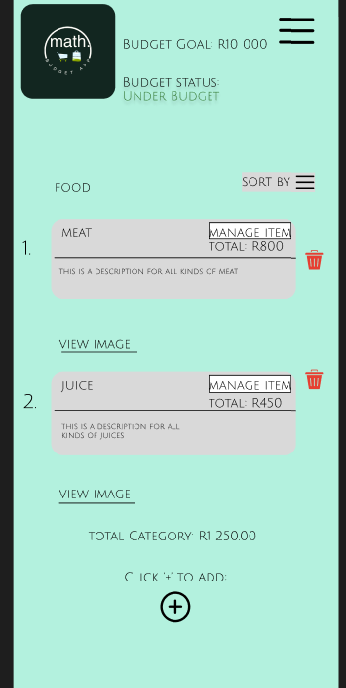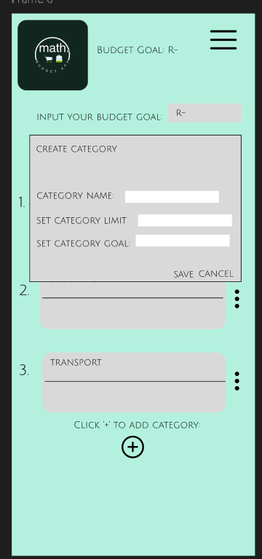

List Page

When the user selects to go into a category, this is the page that will show the list of the items included in the category, the items can be managed and deleted and added.

Category Screen

This the page that the user creates the categories with the options of setting the Name, Category Limit and the Category Goal

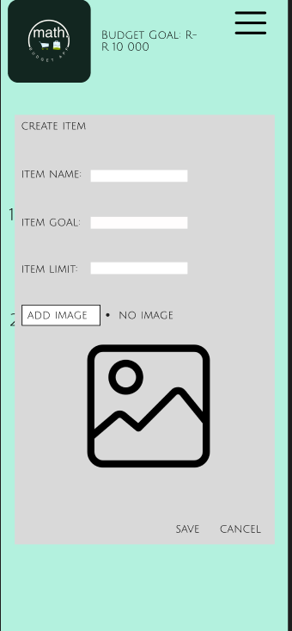

Item Page

This is the page where the user can then add the items to the category by pressing the ‘+’ button then being able to add the Item Name, Item Goal and the Item Limit and the image that can be uploaded as a receipt for the item.

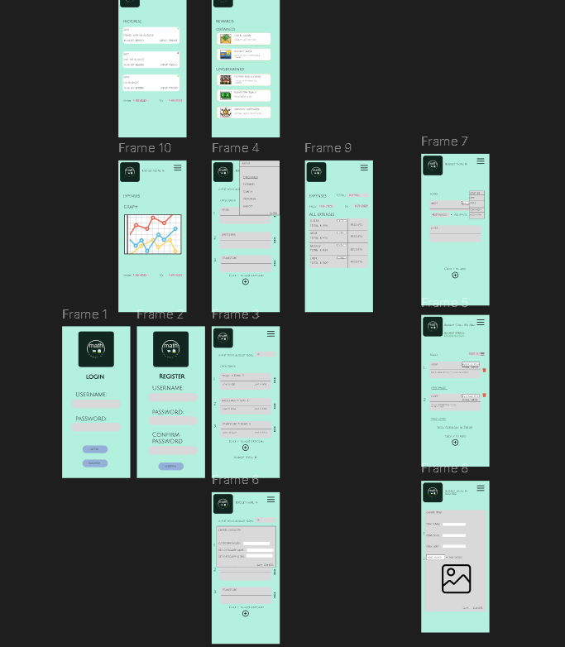

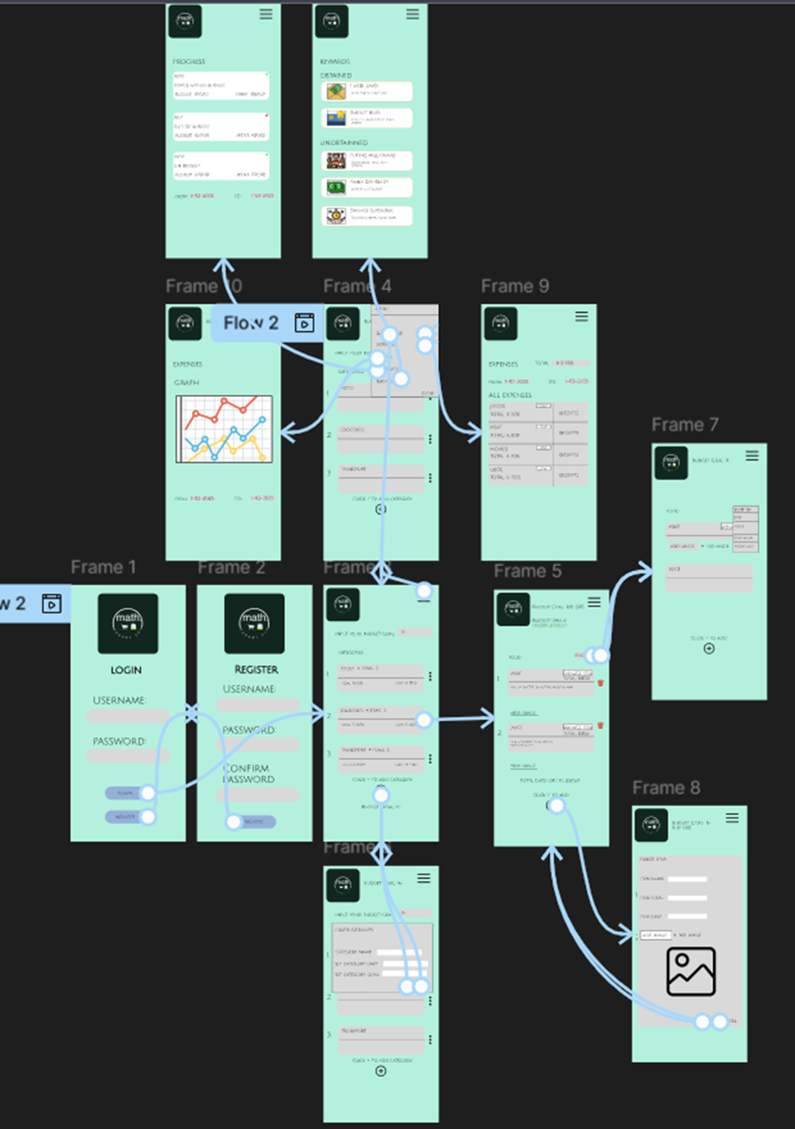  
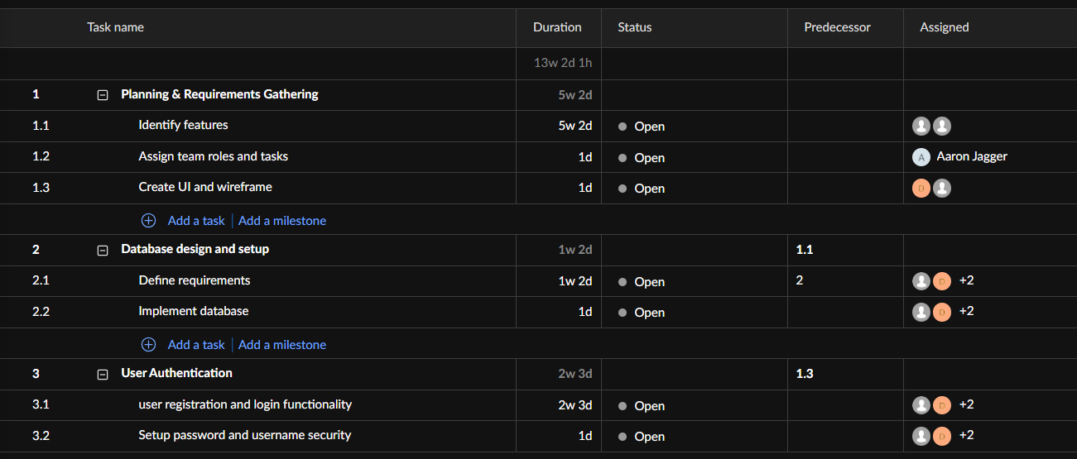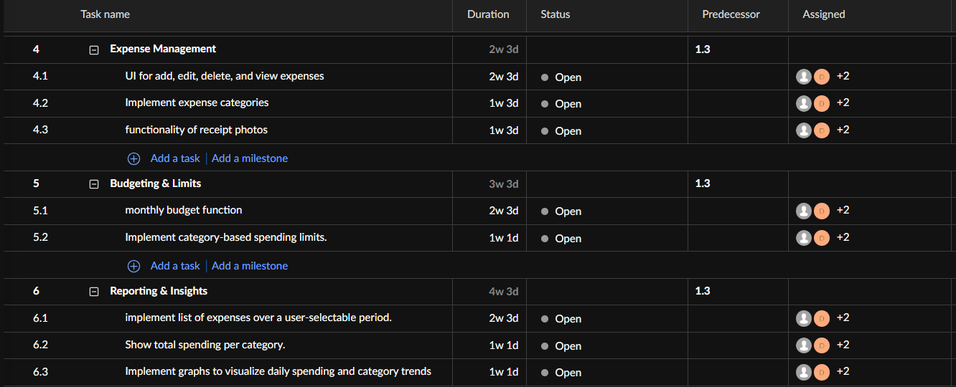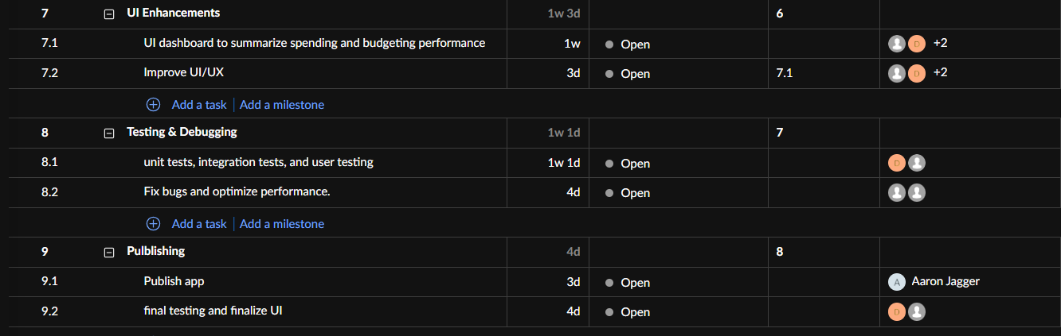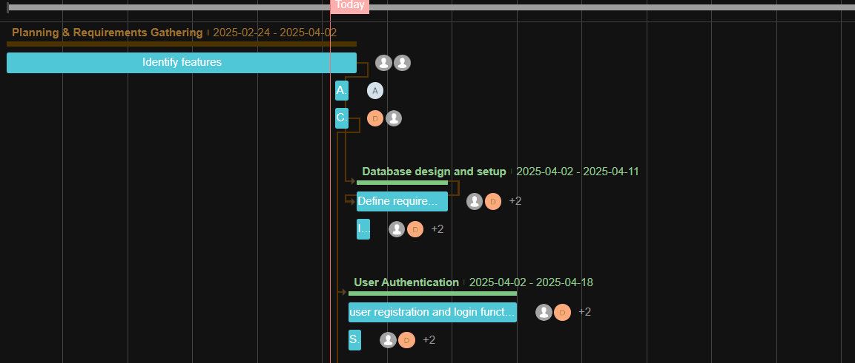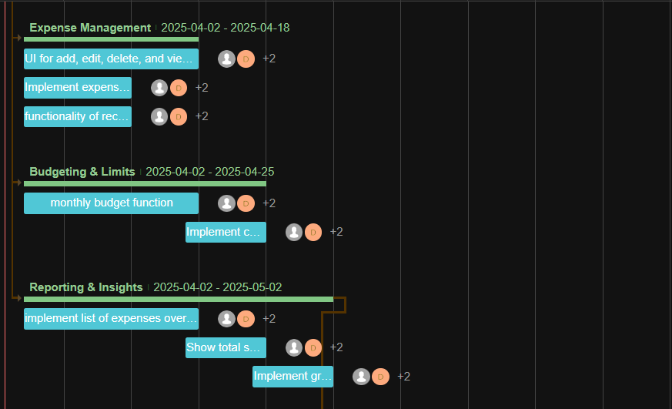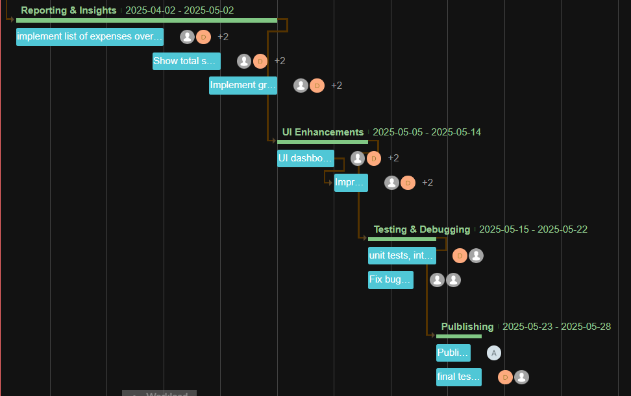

Conclusion

Better than simply a budgeting tool, Pocket Saver Budget is your personal financial assistant, made to streamline money management and assist you in making better informed financial choices. The app's robust features and easy-to-use UI enable users to track spending, create budgets, keep an eye on spending patterns, and even receive awards for saving money.

Pocket Saver Budget guarantees that consumers have total control over their finances by incorporating necessary features like graphical expenditure analysis, expense monitoring, and food list planning. Financial planning becomes more involved and gratifying when the gamification component is added.

In the end, this software is designed to do more than just track data; it assists users in improving their financial practices, cutting back on wasteful spending, and advancing their savings objectives. Pocket Saver Budget is the ideal tool to help you achieve financial success, regardless of your goals—whether they are expense reduction, future savings, or a better understanding of your spending patterns. Take control of your financial future by putting it to use right now!

# References

* *Vault22*. (n.d.). <https://www.vault22.io/>
* SPENDEE a.s. www.spendee.com. (n.d.). *Money Manager & Budget Planner | Spendee*. Copyright 2025 SPENDEE a.s. | All Rights Reserved. <https://www.spendee.com/>
* *YNAB*. (n.d.). <https://www.ynab.com/>